

PUSHING THE CONTAINER ON DOCKERHUB
DevOps Certification Training

support@intellipaat.com
+91-7022374614
US: 1-800-216-8930(Toll Free)

PUSHING THE CONTAINER ON DOCKERHUB
Step 1: The first step is to login, it can be done using the following command:
$ docker login

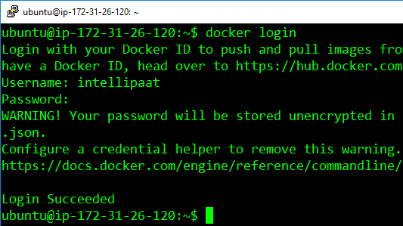
Step 2: Finally, for pushing your container on DockerHub, use the following command
$ docker push <username>/<container-id>

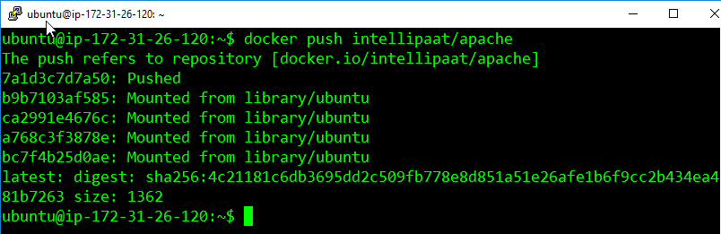

Step 3: You can verify the push on DockerHub
$ docker exec –it <container-id> bash
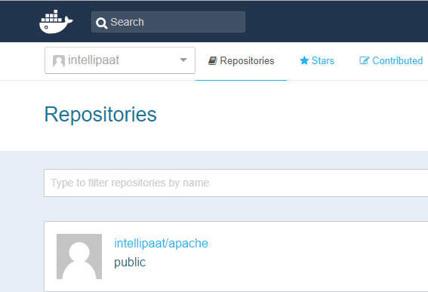
Now anyone, who wants to download this container. Can simply pass the following command:
docker pull intellipaat/apache

